P233Q Supplemental Curriculum Topics / Activities (Grades: 3-5)
Directions: Students will conduct research and use interactive websites to learn about curriculum related topics.
ELA:  Literature | Read a book  https://www.storylineonline.net/books/house-that-jane-built/ | Read a book  https://www.storylineonline.net/books/house-that-jane-built/ | Read a book  https://www.storylineonline.net/books/house-that-jane-built/ | Read a book  https://www.storylineonline.net/books/house-that-jane-built/ | Read a book  https://www.storylineonline.net/books/house-that-jane-built/
Math:  Numbers and Operations | Use a number grid to do math computations  https://www.ixl.com/math/ | Use a number grid to do math computations  https://www.ixl.com/math | Use a number grid to do math computations  https://www.ixl.com/math/ | Use a number grid to do math computations  https://www.ixl.com/math/ | Use a number grid to do math computations  https://www.ixl.com/math/
Science:  Weather and Erosion | Use the attached chart to document today’s weather | Use the attached chart to document today’s weather | Use the attached chart to document today’s weather | Use the attached chart to document today’s weather | Use the attached chart to document today’s weather
S.S:  NY State and Local Gov’t | Identify NY State using a map  http://www.yourchildlearns.com/us_map.htm | Identify NY’s five boroughs using a map  http://ontheworldmap.com/usa/city/new-york-city/nyc-boroughs-map.html | Research and identify the bill of rights  https://bensguide.gpo.gov/bill-of-rights-1789-91 | Identify the three branches of Government  https://bensguide.gpo.gov/search?q=branches+of+government | Research and identify your local government officials  https://www.buildingcongress.com/industry-links/New-York-City-Government-Elected-Officials
Additional  Resources | Practice counting and writing numbers up to 100 | Practice learning/writing your personal information: i.e. first and last name, address and phone number | Review the alphabet letters and their sounds. Identify the vowels and their sounds | Sight word practice: https://sightwords.com/sight-words/dolch/ | Practice asking and answering “wh” questions related to stories read or personal experiences
Learning Websites | https://www.coolmath.com/ | https://www.starfall.com/ | https://pbskids.org/ | https://kids.nationalgeographic.com/ | https://www.timeforkids.com/

Directions: Chart each day’s weather using the pictures provided – draw or cut, glue (or) tape pictures into each box after observing the daily weather. Objective: Students will: (1) keep a weather record to collect data about weather over an extended period of time.
Day 1 | Day 2 | Day 3 | Day 4 | Day 5 | Day 6 | Day 7 | Day 8
Day 9 | Day 10 | Day 11 | Day 12 | Day 13 | Day 14 | Day 15 | Day 16
Day 17 | Day 18 | Day 19 | Day 20 | Day 21 | Day 22 | Day 23 | Day 24
Day 25 | Day 26 | Day 27 | Day 28 | Day 29 | Day 30 | Day 31

Sunny | Partly Sunny | Rainy  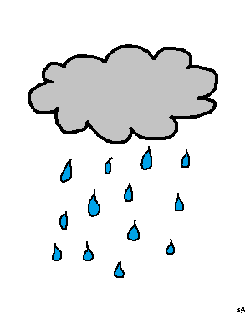 | Snowy  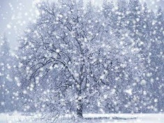 | Cloudy
Sunny | Partly Sunny | Rainy | Snowy | Cloudy
Sunny | Partly Sunny | Rainy | Snowy | Cloudy
Sunny | Partly Sunny | Rainy | Snowy | Cloudy
Sunny | Partly Sunny | Rainy | Snowy | Cloudy
Sunny | Partly Sunny | Rainy  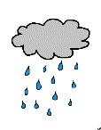 | Snowy | Cloudy

Number and Operations Grid: The number grid can be used as a tool to help students count and solve problems.
Directions: Do addition or subtraction calculations using the number grid.
1 | 2 | 3 | 4 | 5 | 6 | 7 | 8 | 9 | 10
11 | 12 | 13 | 14 | 15 | 16 | 17 | 18 | 19 | 20
21 | 22 | 23 | 24 | 25 | 26 | 27 | 28 | 29 | 30
31 | 32 | 33 | 34 | 35 | 36 | 37 | 38 | 39 | 40
41 | 42 | 43 | 44 | 45 | 46 | 47 | 48 | 49 | 50
51 | 52 | 53 | 54 | 55 | 56 | 57 | 58 | 59 | 60
61 | 62 | 63 | 64 | 65 | 66 | 67 | 68 | 69 | 70
71 | 72 | 73 | 74 | 75 | 76 | 77 | 78 | 79 | 80
81 | 82 | 83 | 84 | 85 | 86 | 87 | 88 | 89 | 90
91 | 92 | 93 | 94 | 95 | 96 | 97 | 98 | 99 | 100

