P233Q Supplemental Curriculum Topics / Activities (K-2)
ELA:  Non-Fiction | Read a non-fiction book  https://www.freechildrenstories.com/ | Read a non-fiction book  https://www.freechildrenstories.com/ | Read a non-fiction book  https://www.freechildrenstories.com/ | Read a non-fiction book  https://www.freechildrenstories.com/ | Read a non-fiction book  https://www.freechildrenstories.com/
Math:  Numbers and Operations | https://www.ixl.com/math | https://www.ixl.com/math | https://www.ixl.com/math | https://www.ixl.com/math | https://www.ixl.com/math
Science:  Weather Watcher | Use the attached chart to document today’s weather | Use the attached chart to document today’s weather | Use the attached chart to document today’s weather | Use the attached chart to document today’s weather | Use the attached chart to document today’s weather
S.S:  The Community | Identify stores in your community | Identify restaurants in your community | Identify streets in your community | Identify the schools in your community | Create a map of your community
Additional Ideas  Resources | Practice counting and writing numbers up to 20 | Practice learning your personal information: i.e. address and phone number | Review the alphabet letters and their sounds | Identify the vowels and their sounds | Practice writing/tracing your first and last name
Learning Websites | https://www.coolmath.com/ | https://www.starfall.com/ | https://pbskids.org/ | https://kids.nationalgeographic.com/ | https://www.timeforkids.com/

Directions: Chart each day’s weather using the pictures provided – draw or cut, glue (or) tape pictures into each box after observing the daily weather. Objective: Students will: (1) keep a weather record to collect data about weather over an extended period of time.
Day 1 | Day 2 | Day 3 | Day 4 | Day 5 | Day 6 | Day 7 | Day 8
Day 9 | Day 10 | Day 11 | Day 12 | Day 13 | Day 14 | Day 15 | Day 16
Day 17 | Day 18 | Day 19 | Day 20 | Day 21 | Day 22 | Day 23 | Day 24
Day 25 | Day 26 | Day 27 | Day 28 | Day 29 | Day 30 | Day 31

Sunny | Partly Sunny | Rainy  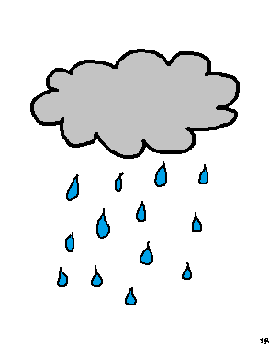 | Snowy | Cloudy
Sunny | Partly Sunny | Rainy | Snowy | Cloudy
Sunny | Partly Sunny | Rainy | Snowy | Cloudy
Sunny | Partly Sunny | Rainy | Snowy | Cloudy
Sunny | Partly Sunny | Rainy | Snowy | Cloudy
Sunny | Partly Sunny | Rainy  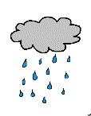 | Snowy | Cloudy
Number and Operations Grid: The number grid can be used as a tool to help students count and solve problems.
Directions: Do addition or subtraction calculations using the number grid.
1 | 2 | 3 | 4 | 5 | 6 | 7 | 8 | 9 | 10
11 | 12 | 13 | 14 | 15 | 16 | 17 | 18 | 19 | 20
21 | 22 | 23 | 24 | 25 | 26 | 27 | 28 | 29 | 30
31 | 32 | 33 | 34 | 35 | 36 | 37 | 38 | 39 | 40
41 | 42 | 43 | 44 | 45 | 46 | 47 | 48 | 49 | 50
51 | 52 | 53 | 54 | 55 | 56 | 57 | 58 | 59 | 60
61 | 62 | 63 | 64 | 65 | 66 | 67 | 68 | 69 | 70
71 | 72 | 73 | 74 | 75 | 76 | 77 | 78 | 79 | 80
81 | 82 | 83 | 84 | 85 | 86 | 87 | 88 | 89 | 90
91 | 92 | 93 | 94 | 95 | 96 | 97 | 98 | 99 | 100

